Aim

Write a program to illustrate how to define and declare a class template for reading two data items from the keyboard and to find their sum.

Experiment - 31

Object Oriented Programming Lab

Syeda Reeha Quasar

14114802719

4C7

# **EXPERIMENT – 31**

## **Aim:**

Write a program to illustrate how to define and declare a class template for reading two data items from the keyboard and to find their sum.

## **Source Code:**

#include <iostream>

using namespace std;

template <typename T>

T sum(T x, T y)

{

    return x + y;

}

int main()

{

    cout << "Sum : " << sum(3, 5) << endl;

    cout << "Sum : " << sum(3.0, 5.2) << endl;

    cout << "Sum : " << sum(3.24234, 5.24144) << endl;

    return 0;

}

## **Output:**

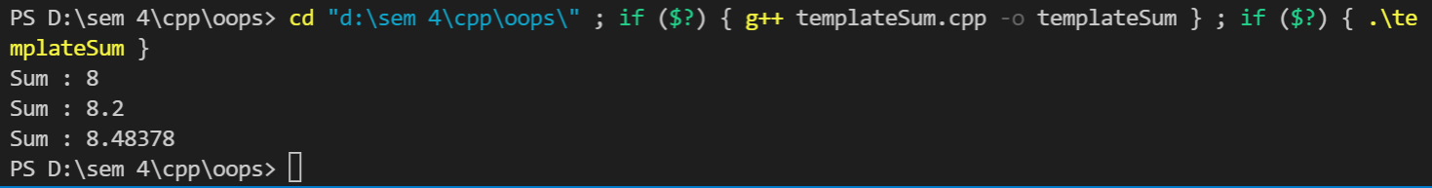

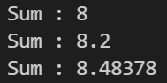

# **Viva Questions**

**Q1). What are templates in C++?**

Ans.

Templates are the foundation of generic programming, which involves writing code in a way that is independent of any particular type.

A template is a blueprint or formula for creating a generic class or a function. The library containers like iterators and algorithms are examples of generic programming and have been developed using template concept.

There is a single definition of each container, such as **vector**, but we can define many different kinds of vectors for example, **vector <int>** or **vector <string>**.

**Q2). How can templates be classified?**

Ans.

**Function Templates:**

We can define a template for a function. For example, if we have an add() function, we can create versions of the add function for adding the int, float or double type values.

**Class Template:**

We can define a template for a class. For example, a class template can be created for the array class that can accept the array of various types such as int array, float array or double array.

**Q3). Write about Function templates.**

Ans.

* C++ supports a powerful feature known as a template to implement the concept of generic programming.
* A template allows us to create a family of classes or family of functions to handle different data types.
* Template classes and functions eliminate the code duplication of different data types and thus makes the development easier and faster.
* Multiple parameters can be used in both class and function template.
* Template functions can also be overloaded.
* We can also use nontype arguments such as built-in or derived data types as template arguments.

**Q4) What is purpose of operator overloading?**

Ans.

The purpose of operator overloading is to provide a special meaning of an operator for a user-defined data type. With the help of operator overloading, you can redefine the majority of the C++ operators. You can also use operator overloading to perform different operations using one operator.

**Q5). What are the benefits of OOPs?**

Ans.

The procedural-oriented languages focus on procedures, with function as the basic unit. You need to first figure out all the functions and then think about how to represent data.

The object-oriented languages focus on components that the user perceives, with objects as the basic unit. You figure out all the objects by putting all the data and operations that describe the user's interaction with the data.

Object-Oriented technology has many benefits:

* *Ease in software design* as you could think in the problem space rather than the machine's bits and bytes. You are dealing with high-level concepts and abstractions. Ease in design leads to more productive software development.
* *Ease in software maintenance*: object-oriented software are easier to understand, therefore easier to test, debug, and maintain.
* *Reusable software*: you don't need to keep re-inventing the wheels and re-write the same functions for different situations. The fastest and safest way of developing a new application is to reuse existing codes - fully tested and proven codes.